A
MAJOR PROJECT REPORT

ON
EXPLAINABLE AI FOR TRAFFIC VIOLATION DETECTION AND RISK SCORING
Submitted in partial fulfillment of the requirement for the award of the degree of

BACHELOR OF TECHNOLOGY

IN
COMPUTER SCIENCE AND ENGINEERING

(Artificial Intelligence &Machine Learning)
BY
A.RITHIKA – 22P61A6605
CH.SRUJANA – 22P61A6637
G.KEERTHI – 22P61A6659

Under the esteemed guidance of
MR.P.SRINIVAS
Assistant Professor



Aushapur(V), Ghatkesar (M), Hyderabad, Medchal –Dist, Telangana–501301.

DEPARTMENT
OF
COMPUTER SCIENCE & ENGINEERING
(Artificial Intelligence & Machine Learning)

CERTIFICATE

This is to certify that the major project titled “Explainable AI for traffic violation detection and risk scoring” submitted by A.Rithika (22P61A6605), Ch.Srujana (22P61A6637), G.Keerthi (22P61A6659) in B.Tech IV-I semester Computer Science & Engineering(Artificial Intelligence & Machine Learning) is a record of the bonafide work carried out by them.
The results embodied in this report have not been submitted to any other University for the award of any degree.

INTERNAL GUIDE
Mr.P.Srinivas

PROJECT COORDINATOR
Mr.P.Srinivas

HEAD OF THE DEPARTMENT
Dr. K. Shirisha Reddy

EXTERNAL GUIDE

DECLARATION

We, A.Rithika , Ch.Srujana , G.Keerthi bearing hall ticket numbers 22P61A6605, 22P61A6637, 22P61A6659 hereby declare that the major project report entitled “Explainable AI for traffic violation detection and risk scoring” under the guidance of Mr.P,Srinivas Department of Computer Science Engineering(Artificial Intelligence & Machine Learning), Vignana Bharathi Institute of Technology, Hyderabad, have submitted to Jawaharlal Nehru Technological University Hyderabad, Kukatpally, in partial fulfilment of the requirements for the award of the degree of Bachelor of Technology in Computer Science and Engineering(Artificial Intelligence & Machine Learning).
This is a record of bonafide work carried out by us and the results embodied in this project have not been reproduced or copied from any source. The results embodied in this project report have not been submitted to any other university or institute for the award of any other degree or diploma.

A.Rithika -22P61A6605
Ch.Srujana -22P61A6637
G.Keerthi-22P61A6659

ACKNOWLEDGEMENT

We are extremely thankful to our beloved Chairman, Dr. N. Goutham Rao and secretary, Dr. G. Manohar Reddy who took keen interest to provide us the infrastructural facilities for carrying out the project work. Self-confidence, hard work, commitment and planning are essential to carry out any task. Possessing these qualities is sheer waste, if an opportunity does not exist. So, we whole- heartedly thank Dr. P. V. S. Srinivas, Principal, and Dr. K. Shirisha Reddy, Head of the Department, Computer Science and Engineering (Artificial Intelligence & Machine Learning) for their encouragement and support and guidance in carrying out the project.
We would like to express our indebtedness to the project coordinator, Mr.P. Srinivas, Assistant Professor, Department of CSE (Artificial Intelligence & Machine Learning) for his valuable guidance during the course of project work.
We thank our Project Guide, Mr.P.Srinivas for providing us with an excellent project and guiding us in completing our mini project successfully.
We would like to express our sincere thanks to all the staff of Computer Science and Engineering(Artificial Intelligence & Machine Learning), VBIT, for their kind cooperation and timely help during the course of our project. Finally, we would like to thank our parents and friends who have always stood by us whenever we were in need of them.

ABSTRACT

Automated traffic surveillance systems are increasingly necessary to handle the growing complexities of urban traffic, yet most existing solutions are limited to rule-based violation detection and lack transparency. It introduces an explainable deep learning-based system for real-time traffic violation detection and driver risk profiling. The system processes live or recorded video streams using video transformers and object detection algorithms to identify traffic infractions such as red-light jumping, lane violations, and wrong-way driving. To improve transparency and user trust, the model integrates post-hoc explainability techniques such as Grad-CAM and LIME to visually justify decisions. In addition, a behavioral profiling engine evaluates each driver's historical violations to assign a dynamic risk score, helping authorities prioritize intervention. The solution is supported by a web-based dashboard that visualizes violations, explanations, andrisk analytics for traffic enforcement teams.

Keywords: Traffic Surveillance, Explainable AI, Video Transformers, Driver Risk Scoring, Grad-CAM, Violation Detection, Computer Vision, Smart Transportation

DEPARTMENT
OF
COMPUTER SCIENCE AND ENGINEERING

(Artificial Intelligence & Machine Learning)

VISION

To achieve global standards of quality in technical education with the help of advanced resources and automated tools to bridge the gap between industry and academia.

MISSION

- Build the students technically competent on global arena through effective teaching learning process and world-class infrastructure.
- Inculcate professional ethics, societal concerns, technical skills and life-long learning to succeed in multidisciplinary fields.
- Establish competency centre in the field of Artificial Intelligence and Machine Learning with the collaboration of industry and innovative research.

PROGRAM EDUCATIONAL OBJECTIVES(PEOs)

PEO 1: Domain Knowledge: Impart strong foundation in basic sciences, Mathematics, Engineering and emerging areas by Advanced tools and Technologies.
PEO 2: Professional Employment: Develop Professional skills that prepare them for immediate employment in industry, government, entrepreneurship and R&D.
PEO 3: Higher Degrees: Motivation to pursue higher studies and acquire masters and research.
PEO4: Engineering Citizenship: Communicate and work effectively, engage in team work, achieve professional advancement, exhibit leadership skills, and ethical attitude with a sense of social responsibility.
PEO 5: Lifelong Learning: Lead edge of the industrial engineering discipline and respond to challenges of an ever-changing environment with the most current knowledge and technology.

PROGRAM OUTCOMES(POs)

Engineering graduates will be able to:

- Engineering Knowledge: Apply the knowledge of mathematics, science, engineering fundamentals, and an engineering specialization to the solution of complex engineering problems.
- Problem Analysis: Identify, formulate, review research literature, and analyze complex engineering problems reaching substantiated conclusions using first principles of mathematics, natural sciences, and engineering sciences.
- Design/development of solutions: Design solutions for complex engineering problems and design system components or processes that meet the specified needs with appropriate consideration for the public health and safety, and the cultural, and environmental considerations.
- Conduct investigations of complex problems: Use research-based knowledge and research methods including design of experiments, analysis and interpretation of data, and synthesis of the information to provide valid conclusions.
- Modern tool usage: Create, select, and apply appropriate techniques, resources, and modern engineering and IT tools including prediction and modeling to complex engineering activities with an understanding of the limitations.
- The engineer and society: Apply reasoning informed by contextual knowledge to assess societal, health, safety, legal and cultural issues, and the consequent responsibilities relevant to professional engineering practice.
- Environment and sustainability: Understand the impact of professional engineering solutions in societal and environmental contexts, and demonstrate the knowledge of, and need for sustainable development.
- Ethics: Apply ethical principles and commit to professional ethics and responsibilities and norms of engineering practice.
- Individual and team work: Function effectively as an individual, and as a member or leader in diverse teams, and in multidisciplinary settings.
- Communication: Communicate effectively on complex engineering activities with the engineering community and with society at large, such as, being able to comprehend and write effective reports and design documentation, make effective Presentations, and give and receive clear instructions.
- Project management and finance: Demonstrate knowledge and understanding of the engineering and management principles and apply these to one’s own work, as a member and leader in a team, to manage projects and in multidisciplinary Environments.
- Life-long learning: Recognize the need for and have the preparation and ability to engage in independent and life-long learning in the broadest context of technological change.

PROGRAM SPECIFIC OUTCOMES (PSOs)

PSO1: Understand and Apply Multi-Disciplinary and core concepts with emerging technologies for sustaining with the Dynamic Industry Challenges.
PSO2: Design Automated Applications in Machine Learning, Deep Learning, Natural Language Processing and Relevant Emerging areas for visualizing, interpreting the datasets.
PSO3: Develop Computational Knowledge, project and Interpersonal skills using innovative tools for finding an elucidated solution of the real-world problems and societal needs.

Course Objective

- Identify and compare technical and practical issues related to the area of course specialization.
- Design and implement projects, including several systems to solve engineering challenges and meet specified requirements.
- Prepare a well-organized report employing elements of technical writing and critical thinking.
- Demonstrate the ability to describe, interpret and analyze technical issues and develop competence in presenting.
- Outline a notated bibliography of research demonstrating scholarly skills.

Course Outcomes

1. Describe fundamental concepts and principles related to projects.

2. Demonstrate how systems operate, including the relationship between hardware and software components.

3. Apply knowledge of programming techniques to design and implement solutions for specific problems.

4. Develop and analyze models for providing solutions to technical problems.

5.Adequate documentation, presentation and visual communication with ethical considerations.

CO–PO Mapping:

PO  CO | PO 1 | PO 2 | PO 3 | PO 4 | PO 5 | PO 6 | PO 7 | PO 8 | PO 9 | PO 10 | PO 11 | PO 12 | PS O1 | PS O2 | PS O3
CO1 | 2 | 3 | 1 | 2 | - | 1 | 1 | 2 | 3 | - | 2 | 3 | 1 | - | 1
CO2 | 2 | 3 | 1 | 2 | 3 | 1 | 1 | 2 | 3 | 3 | 2 | 3 | 3 | - | 2
CO3 | 3 | 3 | 3 | 3 | 3 | 2 | 2 | 3 | 3 | - | 2 | 3 | 3 | 2 | 3
CO4 | 2 | 3 | 3 | 3 | 3 | 2 | 1 | 2 | 3 | - | 3 | 3 | - | 3 | 3
CO5 | - | - | - | - | 1 | 3 | 2 | 3 | 3 | 3 | - | 1 | - | - | 3

Project Objectives

1.Develop an AI-based model for traffic violation detection
To design and implement a machine learning or computer vision system capable of accurately detecting and classifying traffic violations (e.g., speeding, signal jumping, helmet detection) from video or image data in real time.

2. Integrate explainable AI (XAI) techniques for decision transparency
To apply explainable AI methods (such as SHAP, LIME, or attention maps) to make the model’s predictions interpretable, ensuring that enforcement authorities and users understand the reasoning behind each violation detection and risk score.

3. Implement a driver risk scoring system based on violation patterns
To create a dynamic scoring framework that assesses individual driver risk levels by analyzing frequency, severity, and types of violations, supporting data-driven traffic management and road safety improvement.

Project Outcomes

1. functional AI model capable of automatically identifying and classifying various traffic violations from real-time camera for or recorded footage with high accuracy.
2.Explainable Decision Framework
Integration of explainable AI techniques that provide visual and textual explanations for each detected violation, improving system transparency and trust among users and authorities.
3.Driver Risk Scoring Module
A data-driven system that calculates a comprehensive risk score for each driver based on the frequency, severity, and type of violations committed over time.
4. Enhanced Road Safety Insights
Generation of analytical reports and dashboards that help traffic authorities identify high- risk areas, frequent violators, and common violation trends for better enforcement planning.
5.Scalable and Ethical AI Solution
Deployment of an interpretable and scalable AI solution that adheres to fairness, accountability, and privacy principles, promoting responsible use of AI in traffic monitoring.

Project Mapping

PRO1 | 3 | 3 | 3 | 2 | 3 | - | - | - | 2 | 2 | 2 | 3 | 3 | 3 | 3
PRO2 | 3 | 3 | 3 | 3 | 3 | - | - | - | 2 | 3 | 3 | 3 | 3 | 3 | 3
PR03 | 3 | 3 | 2 | 3 | 3 | - | - | - | 3 | 2 | 3 | 3 | 3 | 3 | 3
PRO4 | 3 | 3 | 2 | 2 | 3 | - | - | - | 1 | 2 | 2 | 3 | 3 | 3 | 3
PRO5 | 3 | 3 | 3 | 2 | 3 | 3 | - | 3 | 3 | 3 | 2 | 3 | 3 | 3 | 3

TABLE OF CONTENTS

CONTENT | PAGE NO.
I. Title | i
II. Certificate | ii
III. Declaration | iii
IV. Acknowledgement | iv
V. Abstract | v
1. Introduction  1.1 Objective | 1  1
2. Problem Statement | 2
3. Literature Review | 2-3
4. Proposed Solution  4.1 Methodology  4.1.1 Problem Framing  4.1.2 Data  4.1.3 Data processing and Feature Extraction  4.1.4 Logic & Interaction Design  5. Modules Description  5.1 Data sources  5.2 Processing modules  5.3 User interaction interface  5.4 Backend storage and synchronization  6.Infrastructure  6.1 Software Requirements.  6.2 Hardware Requirements | 4-8  5-8  5  5  5  6  7-9  7  7-8  8-9
7. System Design  7.1 High level Architecture  7.1.1 System Architecture  7.1.3 Model Architecture  7.1.4 Uml Diagrams | 11-23  11-23  11  12-17  18-23
8. Implementation  8.1 Steps taken  8.2 Code Overview  8.3 Challenges Faced  9.Testing Strategy  9.1UI/UX  9.2 Deployment instructions  9.2.1 Frontend deployment  9.2.2 Backend deployment  9.2.3Custom domain setup  9.2.4CI/CD | 22-37  22-23  23-35  36-37  38-39  39-40  39  40  40
10. Evaluations and Results  10.1 Evaluations Metrics  10.2 Results | 41-44  41  42-44
11. Applications and Impact  11.1 Use Cases  11.2 Impact | 45-46  45  45-46
12. Risks and Validation | 46-47
13. Conclusion and Future Work  14.1 Summary  14.2 Future Enhancements | 48  48  48
14. References | 49-50

INTRODUCTION

In recent years, the rapid growth of urbanization and the increasing number of vehicles on roads have made traffic management and safety major concerns for smart cities. Traditional traffic monitoring systems often rely on manual supervision or rule-based detection, which can be time-consuming, error-prone, and lack scalability. To address these challenges, Artificial Intelligence (AI), particularly computer vision and machine learning, is being increasingly used for automatic traffic violation detection and driver risk scoring.
However, while AI models can achieve high accuracy in identifying violations such as speeding, signal jumping, or lane changes, their decision-making process often remains a “black box.” This lack of transparency raises questions about fairness, accountability, and trust—especially when AI-generated evidence is used for legal or administrative purposes. To overcome these limitations, Explainable Artificial Intelligence (XAI) techniques are introduced to make AI decisions interpretable and transparent.
Explainable AI for traffic violation detection and risk scoring enables authorities and users to understand why and how an AI system classified a certain behavior as a violation or assigned a particular risk score. It provides visual and analytical explanations—such as highlighting detected objects, vehicle trajectories, or contributing factors—making the system more reliable, auditable, and ethically sound.
This approach not only improves the credibility and acceptance of AI-based traffic systems but also supports data-driven decision-making in road safety management, policy enforcement, and driver behavior analysis.

  - Objectives
• To develop an AI-based system capable of automatically detecting traffic violations such as over speeding, signal jumping, wrong-lane driving, and helmet or seatbelt violations using real-time video surveillance and sensor data.
• To design a driver risk scoring model that evaluates and ranks drivers or vehicles based on their frequency and severity of violations, promoting safer driving behavior.
• To integrate Explainable AI (XAI) techniques for interpreting and visualizing the AI model’s decisions, ensuring transparency, accountability, and user trust in automated traffic enforcement systems.
• To enhance the interpretability of computer vision models (e.g., YOLO, CNN, or transformers) by identifying and highlighting the key visual features or factors influencing violation detection and risk scoring.
• To support data-driven decision-making for traffic authorities by providing interpretable insights, analytics, and reports on traffic patterns, violations, and high-risk areas.

2. PROBLEM STATEMENT

In many urban areas, traffic violations such as over speeding, signal jumping, and helmet non-compliance are major causes of road accidents and congestion. Traditional surveillance systems rely heavily on manual monitoring, which is time-consuming, error-prone, and lacks transparency in decision-making. Although modern AI-based traffic monitoring systems can automate violation detection, they often function as “black boxes,” providing predictions without explaining how or why a particular decision was made.
This lack of interpretability leads to reduced trust among enforcement agencies and the public, making it difficult to justify penalties or assess driver behavior fairly. There is also a growing need to evaluate drivers’ risk levels based on their violation history to support proactive traffic management and policy-making.
Therefore, there is a need for an explainable AI system that can accurately detect traffic violations, provide transparent and interpretable reasoning behind its decisions, and generate driver risk scores based on behavioral patterns, ensuring fairness, accountability, and improved road safety

3. LITERATURE REVIEW

- Backgroundandmotivation
The authors address a core problem in autonomous-driving and traffic safety research: anticipating accidents early from dashcam (dashboard) video. While deep learning models can achieve strong predictive performance, their black-box nature reduces human trust and makes it difficult to justify decisions in safety-critical contexts. The paper therefore pursues two goals simultaneously: (a) accurate, early anticipation of traffic accidents from short dashcam clips, and (b) providing human-interpretable visual explanations for the model’s predictions to increase trust and interpretability.

- Modelarchitectureandaccident-anticipationpipeline
The proposed system is a two-part pipeline: a feature extraction + temporal modeling stage for accident anticipation, and a post-hoc visual explanation stage. Features are extracted per frame (a convolutional feature extractor), then aggregated temporally using a Gated Recurrent Unit (GRU) network that captures short-term spatio-temporal relationships across frames. The GRU outputs are passed to a classifier that predicts the probability of an imminent accident at each time step (allowing early anticipation).

- Explainabilitymethod:Grad-CAMsaliencymaps
To explain why the network predicts an upcoming accident, the authors apply Grad-CAM to the convolutional feature maps. They compute channel-wise importance weights (gradients averaged spatially), aggregate weighted feature maps, apply ReLU, and upsample the resulting Grad-CAM maps via bilinear interpolation to the input frame size. These saliency heatmaps are superimposed on video frames to provide human-interpretable visual evidence for the model’s decision. The paper also evaluates how well these attention maps align with actual human gaze/attention (human attention maps / fixation points).

- Dataset,training,andevaluationprotocol
The study uses the publicly available Car Crash Dataset (CCD) recorded from dashcams. Videos are trimmed to 5 seconds (50 frames, 10 fps). The dataset has both positive (accident) and negative (no-accident) videos; the authors note the positive class contains ~1,500 accident clips and the negative class ~3,000 non-accident clips. They split the dataset into a training set of 3,600 videos and a testing set of 900 videos. For training they use a loss formulation that emphasizes early anticipation (an exponential cross-entropy scheme that rewards early correct predictions). Evaluation metrics include anticipation time (how many seconds before the event the model predicts it) and average precision; they also quantify alignment between Grad-CAM and human attention using normalized scanpath saliency measures.

- Keyfindingsandperformance
The proposed explainable model achieves strong empirical performance: the paper reports early anticipation (on average ~4.57 seconds before the accident) with high precision (reported ~94.02% average precision). The Grad-CAM based explanations are shown to be human-interpretable and align well with human attention maps (the paper reports a normalized scanpath saliency score ~1.23 for their chosen Grad-CAM variant). The authors conclude that a human-inspired explanation mechanism can both anticipate accidents early and provide transparent reasoning for predictions.

6. Strengths
- Combines a temporal model (GRU) with a post-hoc visual explanation method (Grad-CAM) — a pragmatic approach for explainable video prediction.
- Uses a real dashcam dataset and trains the model to encourage early detection, which is critical for practical safety interventions.
- Quantitatively evaluates both prediction performance and explanation quality (alignment with human attention).

7. Limitations and open issues
- The dataset is trimmed to short clips (5s) — this may limit evaluating long-term contextual cues.
- Grad-CAM is post-hoc and local; it highlights spatial regions but does not provide causal or symbolic explanations (e.g., “vehicle A cut lane at t-2”).
- The architecture and evaluation focus on accident anticipation specifically; adapting it to other traffic-safety tasks (e.g., multi-violation detection, multi-object attribution, or risk scoring per driver) requires design extensions.
- No discussion of bias, fairness, or privacy concerns around continual monitoring is presented in depth.

8.Relevance & adaptation to your project(Explainable AI for Traffic ViolationDetection Risk Scoring)
This paper is directly relevant and provides concrete building blocks you can adapt:
- Temporal modeling: Use GRU/LSTM (or transformers) over frame features to capture violation dynamics (e.g., speeding onset, lane changes).
- Explainability technique: Grad-CAM (or related saliency/attention visualization) can justify violation detections visually (e.g., bounding region for running a red light). For richer explanations combine Grad-CAM with object-level attribution (which object triggered the score) or concept-based explanations (TCAV).
- Early detection & loss design: The idea of shaping the loss to encourage early detection can be repurposed to detect violations as early as possible (e.g., penalize late detections).
- Evaluation: Adopt both predictive metrics (precision, recall, F1, detection latency) and explanation metrics (alignment with human annotations or human attention maps) to show interpretability.
- Driver risk scoring: The paper’s approach to per-video prediction can be extended to per-driver risk — aggregate per-event detections over time and weigh by severity and frequency to compute a running risk score. Combine visual explanations with a textual justification for each risk component (e.g., “3 helmet violations in 30 days → +X risk”).

4. PROPOSED SOLUTION

1.Hybrid Vision–Temporal Understanding Model (ViT+BiLSTM)
The system combines Vision Transformers (ViT) for spatial feature extraction with Bidirectional Long Short-Term Memory (BiLSTM) networks for temporal sequence modeling. This hybrid design enables the model to capture both frame-level spatial cues and time-dependent motion patterns from traffic surveillance videos. The ViT learns attention-based spatial representations of vehicles, lanes, and signals, while BiLSTM captures the evolution of these features across frames to detect violations in real time or during post-incident analysis.

2.Multi-Violation Detection Module’
The model is trained to recognize multiple categories of traffic violations, including overspeeding, signal jumping, helmet non-usage, and wrong-lane driving. The detection pipeline processes live or recorded video streams, identifies relevant vehicles, and classifies the observed behavior using learned spatio-temporal patterns. The use of transformer attention enhances the model’s ability to handle complex traffic scenes with occlusions and varying lighting conditions.

3.Explainable AI Integration (Grad-CAMandSHAP)
To ensure transparency and trust in AI decisions, Explainable AI (XAI) techniques such as Grad-CAM and SHAP (SHapley Additive exPlanations) are incorporated. Grad-CAM generates heatmaps that visually highlight the regions of interest influencing the violation detection (e.g., the traffic signal or vehicle region), while SHAP provides quantitative feature-level contributions, explaining why a certain behavior was classified as a violation. These explanations enhance interpretability for enforcement officers and the general public.

4.Driver Risk Scoring Engineusing Graph Neural Networks(GNN)
Beyond individual event detection, the system introduces a Driver Risk Scoring Engine that employs a Graph Neural Network to analyze spatio-temporal relationships between drivers, locations, and historical violation patterns. Each driver is represented as a node in the graph, with edges encoding interactions such as shared locations, time patterns, or violation co-occurrences. The GNN learns risk propagation across this network, producing a dynamic, data-driven risk score for each driver that can support targeted awareness campaigns and policy interventions.

5.Interactive Web-Based Dashboard
A web-based visualization dashboard presents detected violations, AI explanations, and driver risk analytics in a user-friendly format. The dashboard supports both real-time monitoring and offline analysis, allowing traffic enforcement authorities to review incident videos, examine visual explanations, and assess driver risk levels. Interactive charts and maps display violation density by region, time, and driver category to aid in strategic traffic management.

6.Real-TimeandScalableDeployment
The system supports real-time inference through optimized model compression and GPU-enabled streaming, while also offering offline batch processing for recorded surveillance data. This flexibility enables deployment within traffic command centers or integration with existing smart-city surveillance infrastructure

4.1 Methodology

4.1.1Problem Framing

With the rapid increase in urban traffic density, road safety and traffic law enforcement have become major challenges for modern cities. Conventional monitoring systems rely heavily on manual observation or rule-based automation, which are prone to human error, inefficiency, and limited scalability. Although recent advancements in AI-powered video analytics have improved the accuracy of traffic violation detection, most existing models operate as black boxes — they predict violations without providing understandable reasoning behind their decisions.

This lack of explainability and transparency poses a significant barrier to real-world adoption, as enforcement authorities and the public must be able to trust the system’s decisions, especially when these lead to penalties or legal actions. Moreover, current systems primarily focus on isolated violation detection and do not evaluate overall driver behavior or risk levels across multiple events and contexts.

To address these limitations, the problem can be framed as follows:

Automated DetectionChallenge
How can an AI system accurately detect multiple types of traffic violations (e.g., overspeeding, signal jumping, wrong-lane driving) from real-time video streams while maintaining high robustness under varying environmental and traffic conditions?

Explainability Challenge
How can the system make its decisions interpretable and justifiable, allowing enforcement authorities to visualize and understand why a particular action was flagged as a violation, thereby improving accountability and user trust?

Risk Assessment Challenge
How can we design a mechanism to quantitatively assess driver risk by analyzing patterns and relationships between historical violations, driver behavior, location, and time — enabling proactive and data-driven traffic management

Integrationand Deployment Challenge
How can such an explainable AI system be integrated into existing traffic command center infrastructure to support both real-time monitoring and offline analysis, ensuring scalability, responsiveness, and ease of use?

4.1.2 Data

1. Sources:

Traffic surveillance cameras (live & recorded feeds)

Public datasets – AI City Challenge, Traffic Violation Dataset (TVD), Car Crash Dataset (CCD)

Historical traffic violation logs from local authorities

2. Data Types:

Video clips (20–30 sec, 30 FPS, HD quality)

Metadata – timestamp, location, weather, camera ID

Driver/vehicle data – anonymized ID, past violations

Violation labels – over speeding, signal jumping, helmet non-usage, wrong-lane driving

3. Preprocessing:

Frame extraction & resizing (224×224 px)

Data labeling using tools (e.g., CVAT)

Normalization & augmentation for better accuracy

Feature extraction via Vision Transformer (ViT)

Temporal sequencing using BiLSTM

Graph creation for driver–violation–location relations (for GNN)

Sample Stats:

5,000 video clips (~150,000 frames)

4. violation categories

2,000 driver IDs, ~10,000 graph relations

5. Outputs:

Detected violations with Grad-CAM/SHAP explanations

Driver risk scores and violation trends

Dashboard-ready analytics for visualization

6. Privacy:All personal or identifiable information anonymized or blurred

4.1.3 Data Processing & Feature Extraction

1. Data Cleaning & Preparation
- Remove corrupted or low-quality video clips.
- Standardize video formats (MP4, 30 FPS, 720p/1080p).
- Extract metadata such as timestamp, location, and camera ID.
2. Frame Extraction
- Convert video streams into individual frames at fixed intervals (e.g., every 0.1s).
- Store frames with corresponding timestamps for temporal analysis.
3. Annotation and Labeling
- Label frames or sequences for specific violations: over speeding, red-light jump, helmet absence, wrong-lane usage.
- Use annotation tools like CVAT or LabelImg for bounding boxes or region labels.
4. Image Preprocessing
- Resize frames to 224×224 pixels for Vision Transformer (ViT) input.
- Apply normalization and augmentation (rotation, flipping, brightness changes) to improve model robustness.
- Convert data into batches and tensors for training.

5. Feature Extraction using Vision Transformer (ViT)
- Each frame is divided into small image patches (e.g., 16×16).
- Patches are embedded into feature vectors and passed through Transformer layers.
- ViT learns spatial features such as vehicle shape, position, traffic signals, and lane markings.
6. Temporal Feature Modeling using BiLSTM
- Sequence of ViT embeddings from consecutive frames is passed to a BiLSTM network.
- BiLSTM captures temporal dependencies — how motion, signal state, or vehicle behavior changes over time.
- Outputs a time-aware representation useful for identifying violations.
7. Explainable Feature Analysis (XAI)
- Apply Grad-CAM to visualize important regions influencing predictions.
- Use SHAP values to measure each feature’s contribution to the decision.
8. Feature Output
- Extracted features are stored as embeddings or vectors.
- These are fed into classifiers for violation detection or into a Graph Neural Network (GNN) for risk scoring.

4.1.5 Logic & Interaction Design
1. System Logic
- Step 1: Video Input
  - The system receives live or recorded traffic camera video streams.
- Step 2: Frame Extraction & Preprocessing
  - Frames are extracted from video and preprocessed (resize, normalize, augment).
- Step 3: Violation Detection
  - Vision Transformer (ViT) extracts spatial features from each frame (vehicles, signals, lanes).
  - BiLSTM analyzes the temporal sequence of frames to detect motion-based violations such as over speeding or red-light jumping.
  - The model outputs the type of violation and its confidence score.
- Step 4: Explainability (XAI Layer)
  - Grad-CAM generates visual heatmaps highlighting regions responsible for the decision (e.g., signal light, vehicle).
  - SHAP provides numerical feature importance explaining why the model classified it as a violation.
- Step 5: Risk Scoring
  - Detected violations are linked with driver IDs and historical data.
  - A Graph Neural Network (GNN) analyzes relations between drivers, locations, and times to generate a driver risk score.
- Step 6: Storage and Analytics
  - All results (violations, risk scores, explanations) are stored in a database for further analysis.
- Step 7: Visualization and Reporting
  - The processed data is displayed through a web-based dashboard, showing live feeds, violation alerts, Grad-CAM visualizations, and driver risk statistics.

2. Design Highlights
- Modular pipeline for detection, explainability, and scoring.
- Intuitive dashboard interface with real-time alerts.
- Supports both real-time and offline analysis modes.
- Transparent and explainable outputs for decision accountability.

5. MODULES DESCRIPTION
1. Data Acquisition & Preprocessing: Collects and prepares traffic images/videos for model train.
2. Violation Detection: Detects traffic rule violations using computer vision models.
3. Risk Scoring: Assigns driver or vehicle risk levels based on violation patterns.
4. Explainable AI: Provides visual and textual explanations for AI decisions.
5. Database & Backend: Stores violation data, risk scores, and user history.
6. User Interface: Displays detected violations, risk scores, and explanations interactively.

5.1 Data Sources
1. CCTV Traffic Cameras
Real-time video feeds from city surveillance systems or highway monitoring units.
Provide authentic data on various traffic conditions and violations (signal jump, no helmet, lane change).
2. Open Traffic Datasets
Publicly available datasets such as UA-DETRAC, AI City Challenge, TRANCOS, and TrafficNet.
Contain labeled images and videos of vehicles, pedestrians, and violations for model training and testing.
3. Government Transport Databases
Contain historical data of registered vehicles, driver information, and previous violations.
Useful for linking detection results to real identities and analyzing risk trends.
4. Dashcam Footage
Videos recorded from police or personal vehicle cameras.
Provide close-up views of on-road behaviors and rare violation cases.

5. Synthetic / Simulated Data
Generated using traffic simulators like CARLA or SUMO.

5.2 Processing Modules

1. Data Preprocessing Module

Cleans and formats images/videos from various sources.

Performs frame extraction, resizing, normalization, and augmentation.

Labels objects like vehicles, signals, helmets for model training.

2. Object Detection Module

Uses deep learning (e.g., YOLO, Faster R-CNN) to detect vehicles, people, and traffic elements.

Identifies rule violations such as red-light jump, over-speeding, or no-helmet.

3. Feature Extraction Module

Extracts key features like vehicle type, speed, direction, and violation frequency.

Converts visual and contextual data into numerical form for risk analysis.

4. Risk Analysis & Scoring Module

Applies ML models to assign a risk score (Low/Medium/High).

Considers violation severity, repetition, and driving context.

5. Explainable AI (XAI) Module

Uses LIME, SHAP, or Grad-CAM to interpret model outputs.

Provides visual or textual reasoning for each violation or risk score.

6. Reporting & Storage Module

Stores processed data, images, and risk results in a database.

Generates reports and dashboards for users or authorities.

5.3 User Interaction Interfaces

1. Admin Dashboard

Allows traffic authorities to view detected violations and risk scores.

Displays live camera feeds, violation history, and system analytics.

Enables management of users, cameras, and data sources.

2. User (Driver) Portal

Lets drivers log in to check their violation history and risk level.

Shows visual evidence (images/videos) and explanations for each violation.

Provides suggestions to improve driving behavior.

3. Live Monitoring Interface

Streams real-time video with AI overlays showing detected vehicles and violations.

Highlights detected violations instantly with bounding boxes and alerts.

4. Report & Analytics Interface

Generates violation trends, area-wise heatmaps, and driver performance summaries.

Provides statistical charts for decision-making and policy planning.

5. Alert & Notification Interface

Sends instant alerts to authorities or drivers via SMS, email, or app notification.

Notifies when high-risk behavior or repeated violations are detected.

5.4 Backend Storage & Synchronization

1. Database Storage Module

Stores all violation records, vehicle/driver details, and risk scores.

Uses SQL (MySQL/PostgreSQL) or NoSQL (MongoDB) databases for scalability.

Maintains separate tables for users, violations, video logs, and model outputs.

2. Media Storage Module

Saves images, video clips, and AI-generated visual explanations.

Uses cloud storage (AWS S3, Google Cloud Storage) or local servers for large video data.

3. Model Output Storage

Logs AI model predictions, confidence scores, and XAI explanations.

Enables later review, auditing, and retraining of models.

4. Synchronization Module

Ensures real-time syncing between cameras, servers, and dashboards.

Uses APIs, Web Sockets, or MQTT for live updates and bidirectional communication.

Maintains data consistency across distributed systems (e.g., multiple camera nodes).

5. Backup & Recovery Module

Performs scheduled backups of databases and media files.

Provides recovery mechanisms in case of system failure or data loss.

1. DatabaseStorageModule

The Database Storage Module is responsible for managing all structured data within the system. It stores critical information such as traffic violation records, driver and vehicle details, and computed risk scores. Depending on system requirements, it can utilize relational databases like MySQL or PostgreSQL for structured querying and data integrity, or NoSQL databases like MongoDB for flexibility and scalability with large and semi-structured datasets.
The data is organized into multiple tables or collections, including:

Users/Drivers Table: Stores personal and identification details of drivers.

Violations Table: Contains details of each violation, including type, timestamp, and location.

Vehicle Table: Maintains vehicle-related information linked to drivers.

Video Logs Table: Stores references to recorded video segments.

Model Outputs Table: Stores AI predictions and related metadata.
This modular structure ensures efficient data retrieval, supports complex queries for analytics, and maintains consistency across the system.

2. Media Storage Module

The Media Storage Module handles all unstructured and high-volume data, such as images, video recordings, and AI-generated visual explanations (e.g., heatmaps from Grad-CAM). Since video data can be large and continuously generated, this module relies on scalable storage solutions such as cloud platforms (AWS S3, Google Cloud Storage) or high-capacity local servers.
The system typically stores:

Violation snapshots (images)

Short video clips of incidents

Explainabilityvisualshighlightingdetectedviolations
Efficient indexing and linking mechanisms are used to associate media files with corresponding database records. This ensures quick access for dashboards, audits, and user portals without overloading the primary database.

3. Model Output Storage

This module is dedicated to storing outputs generated by AI models. It records:

Predicted violation types

Confidence scores for each prediction

Explainable AI outputs (e.g., SHAP values, Grad-CAM maps)

Inferencetimestampsandmodelversiondetails
Maintaining this information is crucial for traceability and transparency, allowing authorities to verify how decisions were made. It also supports model performance evaluation, debugging, and continuous improvement through retraining. Historical model outputs can be analyzed to detect biases, improve accuracy, and ensure compliance with regulatory standards.

4.Synchronization Module

The Synchronization Module ensures seamless and real-time communication between different system components, including traffic cameras, backend servers, databases, and user interfaces. Since the system operates in a distributed environment with multiple data sources, synchronization is criticalfor maintaining data consistency and low-latency updates.
This module uses technologies such as:

REST APIs for standard data exchange

WebSockets for real-time, continuous updates to dashboards

MQTT protocols for lightweight communication with IoT-based camera devices
It enables:

Instant updating of violation data on dashboards

Real-time notification delivery

Consistent data across multiple nodes (e.g., different city locations or camera networks)
This ensures that all stakeholders receive accurate and up-to-date information without delays.

Backup &RecoveryModule
The Backup & Recovery Module ensures system reliability and data protection. It performs regular, automated backups of both structured data (databases) and unstructured data (media files). Backup strategies may include:

Full backups at scheduled intervals

Incremental backups to capture recent changes

Cloud-basedredundancyfordisasterrecovery
In case of system failure, data corruption, or cyber incidents, the module provides recovery mechanisms to restore the system to its previous stable state. This minimizes downtime and preventsdataloss.
Additionally, it ensures compliance with data retention policies and enhances overall system robustness.

OverallSummary
The Backend Storage & Synchronization layer forms the foundation of the system by ensuring efficient data management, secure storage of large multimedia content, transparency of AI outputs, real-time system coordination, and reliable data protection. It enables the smooth functioning of all front-end interfaces and analytical components while maintaining scalability, consistency, and fault tolerance.

6. Infrastructure

1. Database Storage Module

Stores all violation records, vehicle/driver details, and risk scores.

Uses SQL (MySQL/PostgreSQL) or NoSQL (MongoDB) databases for scalability.

Maintains separate tables for users, violations, video logs, and model outputs.

2. Media Storage Module

Saves images, video clips, and AI-generated visual explanation

Uses cloud storage (AWS S3, Google Cloud Storage) or local servers for large video data.

3. Model Output Storage

Logs AI model predictions, confidence scores, and XAI explanations.

Enables later review, auditing, and retraining of models.

4. Synchronization Module

Ensures real-time syncing between cameras, servers, and dashboards.

Uses APIs, WebSockets, or MQTT for live updates and bidirectional communication.

Maintains data consistency across distributed systems (e.g., multiple camera nodes).

5. Backup & Recovery Module

Performs scheduled backups of databases and media files.

Provides recovery mechanisms in case of system failure or data loss.

6.1 Software Requirements
1. Operating System: Windows 10/11, Linux (Ubuntu), or Server OS.
2. Programming Languages: Python (for AI/ML), JavaScript (for frontend)
3.Frameworks & Libraries:
AI/ML: TensorFlow, PyTorch, OpenCV, Scikit-learn.
Explainability: LIME, SHAP, Grad-CAM.
Web Frameworks: Flask/Django (backend), React/Angular (frontend).
Database: MySQL / PostgreSQL / MongoDB.
Visualization: Matplotlib, Seaborn, Power BI, or Grafana for analytics.
4. APIs: REST or WebSocket APIs for communication.
5. Version Control: Git / GitHub for code management.

6.2 Hardware Requirements
1. Server Machine:
CPU: Intel i7 / AMD Ryzen 7 or higher.
GPU: NVIDIA RTX 3060 or higher (for training AI models).
RAM: 16–32 GB.
Storage: 1 TB HDD or 512 GB SSD.
2. Edge / Camera Devices:
HD CCTV or IP Cameras (1080p+).
Raspberry Pi / Jetson Nano for on-site AI inference (optional).
3. User Systems:
Standard PC or laptop for admin and driver access. 1. Server Machine:
CPU: Intel i7 / AMD Ryzen 7 or higher.
GPU: NVIDIA RTX 3060 or higher (for training AI models).
RAM: 16–32 GB.
Storage: 1 TB HDD or 512 GB SSD.
2. Edge / Camera Devices:
HD CCTV or IP Cameras (1080p+).
Raspberry Pi / Jetson Nano for on-site AI inference (optional).
3. User Systems:
Standard PC or laptop for admin and driver access.
Stable internet connection and web browser

7. SYSTEM DESIGN

7.1 High-Level Architecture
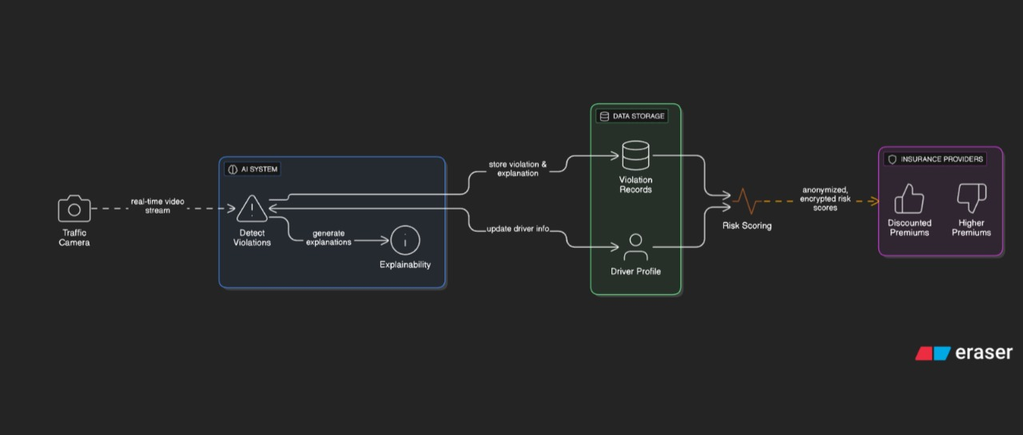
5.1.3 System architecture

The system architecture represents an AI-driven traffic violation detection and risk assessment pipeline with explainability and insurance integration.
1. Data Acquisition (Traffic Camera)
Real-time video streams are captured from traffic cameras. These streams act as the primary input source for the system.
2. AI System (Violation Detection & Explainability)
The incoming video is processed by an AI module that:
- Detects traffic violations (e.g., speeding, signal jumping).
- Generates explanations for each detected violation to ensure transparency (Explainable AI).
This module outputs both violation data and corresponding explanations.
3. Data Storage Layer
The processed information is stored in a structured database consisting of:
- Violation Records: Historical log of detected violations.
- Driver Profile: Updated driver-specific data including behavior patterns.
The system continuously updates driver information and stores explanations for future reference and auditing.
4. Risk Scoring Engine
Using stored violation data and driver profiles, a risk scoring mechanism computes a driver risk score.
- The scoring considers frequency, severity, and patterns of violations.
5. Privacy-Preserving Data Sharing
Before external sharing:
- Risk scores are anonymized and encrypted to ensure privacy and security.
6. Insurance Provider Integration
Insurance companies receive the processed risk scores and use them to adjust premiums:
- Lower risk → Discounted premiums
- Higher risk → Increased premiums
Overall Flow:
Traffic Camera → AI Detection & Explainability → Data Storage → Risk Scoring → Secure Sharing → Insurance Decision System
This architecture ensures real-time monitoring, transparency through explainable AI, secure data handling, and practical application in insurance risk evaluate

7.1.4 Uml Diagrams

Use case diagram:
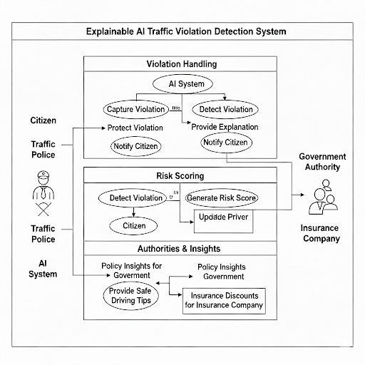

The diagram illustrates an Explainable AI Traffic Violation Detection System structured into three main functional layers: Violation Handling, Risk Scoring, and Authorities & Insights, involving key stakeholders such as citizens, traffic police, government authorities, and insurance companies.

1. Violation Handling Layer
This layer manages the detection and communication of traffic violations using an AI system.
- Capture Violation: Traffic cameras or monitoring systems capture real-time violations.
- Detect Violation: The AI system processes the captured data to identify violations.
- Provide Explanation: The system generates interpretable explanations for each detected violation (Explainable AI).
- Protect Violation Data: Ensures secure handling and storage of violation information.
- Notify Citizen: Citizens are informed about the violation along with the explanation.
This layer ensures transparency, accountability, and user awareness.

2. Risk Scoring Layer
This layer evaluates driver behavior and assigns a risk level.
- Detect Violation (Input): Uses violation data from the previous layer.
- Citizen Mapping: Associates violations with the respective citizen/driver.
- Generate Risk Score: Computes a risk score based on frequency and severity of violations.
- Update Driver Profile: Continuously updates the driver’s record with new violations and risk scores.
The generated risk score is shared with:
- Government Authorities for monitoring and regulation.
- Insurance Companies for premium adjustments.

3. Authorities & Insights Layer
This layer provides actionable insights and decision support.
- Policy Insights for Government: Helps authorities design traffic policies and enforcement strategies.
- Provide Safe Driving Tips: Offers recommendations to citizens to improve driving behavior.
- Insurance Insights: Enables insurance companies to offer discounts or adjusted premiums based on driver risk profiles.

Overall Workflow:
Violation Capture → AI Detection & Explanation → Citizen Notification → Risk Score Generation → Driver Profile Update → Insights for Government & Insurance

This architecture integrates explainable AI with traffic monitoring, ensuring transparency, improved road safety, data-driven policymaking, and dynamic insurance evaluation.

Class Diagram:
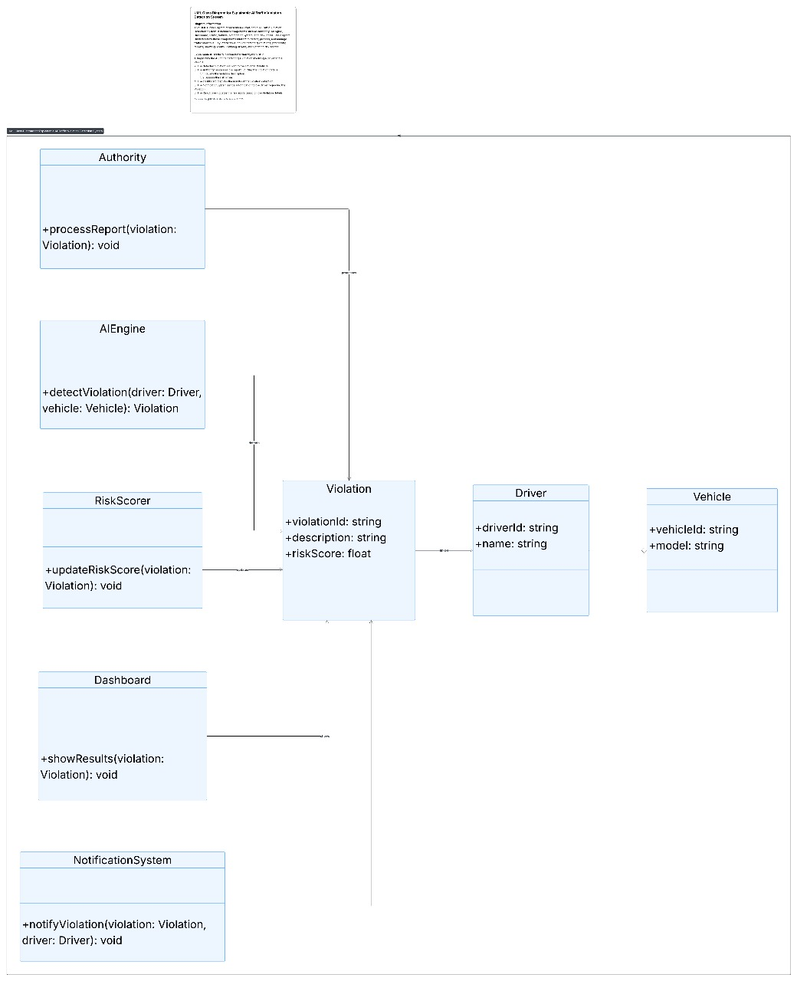

The diagram represents a UML class diagram for an AI-based traffic violation detection and management system. It defines the system structure through classes, their attributes, methods, and relationships.

1. Core Entity Classes
Violation
- Attributes:
  - violationId: string
  - description: string
  - riskScore: float
- Role: Central entity that stores details of each detected traffic violation along with its computed risk score.
- Relationships: Connected to Driver, Vehicle, and multiple system components.
Driver
- Attributes:
  - driverId: string
  - name: string
- Role: Represents the individual responsible for the violation.
Vehicle
- Attributes:
  - vehicleId: string
  - model: string
- Role: Represents the vehicle involved in the violation.

2. Functional Classes
AIEngine
- Method:
  - detectViolation(driver: Driver, vehicle: Vehicle): Violation
- Role: Detects violations using AI techniques by analyzing driver and vehicle data, and generates a Violation object.
RiskScorer
- Method:
  - updateRiskScore(violation: Violation): void
- Role: Calculates and updates the risk score associated with a violation based on severity and historical behavior.
Authority
- Method:
  - processReport(violation: Violation): void
- Role: Represents traffic authorities responsible for reviewing and processing violation reports.
Dashboard
- Method:
  - showResults(violation: Violation): void
- Role: Provides a user interface for visualizing violation details and system outputs.
NotificationSystem
- Method:
  - notifyViolation(violation: Violation, driver: Driver): void
- Role: Sends notifications to drivers regarding detected violations.

3. Relationships and Interactions
- The AIEngine creates a Violation by analyzing Driver and Vehicle data.
- The Violation is associated with both Driver and Vehicle, establishing a link between them.
- The RiskScorer updates the riskScore attribute of the Violation.
- The Authority processes the violation for enforcement or legal actions.
- The Dashboard displays violation information for monitoring and analysis.
- The NotificationSystem informs the driver about the violation and relevant details.

4. Overall Workflow
Driver & Vehicle → AIEngine (detectViolation) → Violation Created → RiskScorer (updateRiskScore) → Authority (processReport) → Dashboard (display results) → NotificationSystem (notify driver)

This class diagram clearly separates responsibilities across components, ensuring modularity, scalability, and maintainability while supporting AI-based violation detection, risk evaluation, and communication.

Sequence diagram:

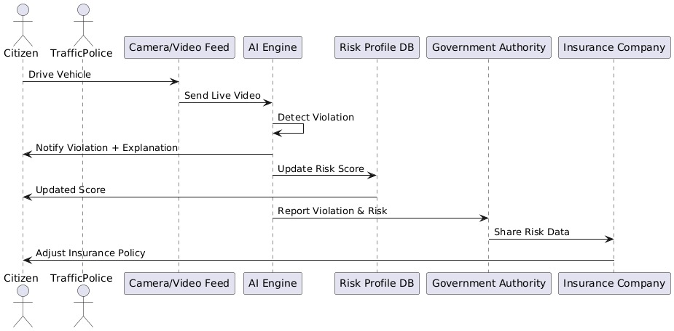

The diagram represents a sequence diagram illustrating the end-to-end workflow of an Explainable AI-based traffic violation detection and risk assessment system. It shows the interaction between different entities over time.

1. Participants (Actors and Systems)
- Citizen – Driver of the vehicle
- Traffic Police – Monitoring authority
- Camera/Video Feed – Captures live traffic data
- AI Engine – Detects violations and generates explanations
- Risk Profile Database – Stores driver risk scores
- Government Authority – Receives violation reports
- Insurance Company – Adjusts insurance policies

2. Sequence of Interactions
- Drive Vehicle
The citizen operates a vehicle on the road, monitored by traffic police systems.
- Send Live Video
The camera/video feed continuously sends real-time video data to the AI Engine.
- Detect Violation
The AI Engine processes the video stream and identifies any traffic violations.
- Notify Violation + Explanation
Once a violation is detected, the AI Engine sends a notification along with an explainable justification to the citizen.
- Update Risk Score
The AI Engine updates the driver’s risk score in the Risk Profile Database based on the detected violation.
- Updated Score
The updated risk score is reflected and can be accessed for further processing.
- Report Violation & Risk
The system reports the violation details and associated risk score to the Government Authority.
- Share Risk Data
The Government Authority shares relevant risk data with the Insurance Company.
- Adjust Insurance Policy
Based on the received risk profile, the Insurance Company adjusts the citizen’s insurance policy (e.g., premium increase or discount).

3. Overall Flow
Citizen Driving → Video Capture → AI Detection → Explanation & Notification → Risk Score Update → Government Reporting → Insurance Adjustment

This sequence diagram highlights real-time processing, explainability, continuous risk evaluation, and integration with government and insurance systems for decision-making.

Activity Diagram:
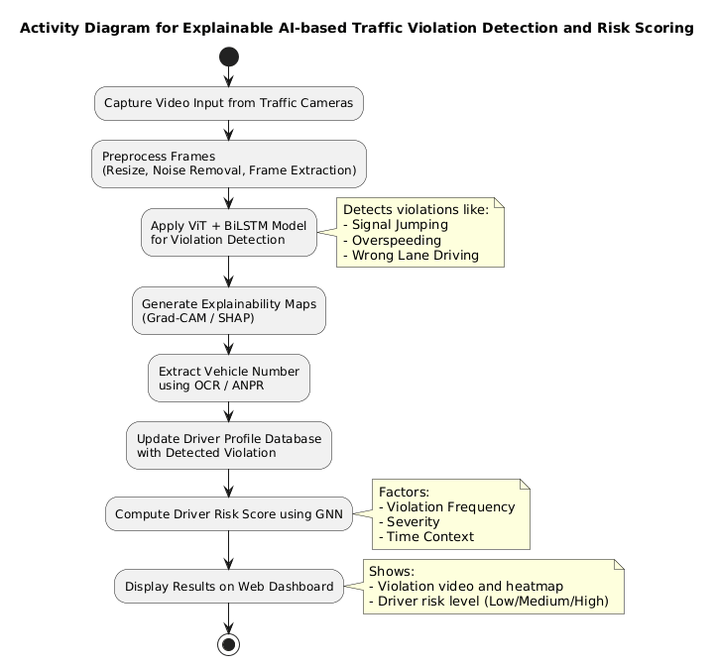

The diagram Activity Diagram for an Explainable AI-based Traffic Violation Detection and Risk Scoring system, showing the step-by-step workflow from data acquisition to result visualization.

1. Start and Data Acquisition
The process begins with capturing video input from traffic cameras, which continuously monitor road activity.

2. Preprocessing
The captured video frames undergo preprocessing to improve data quality:
- Resizing frames
- Noise removal
- Frame extraction
This step ensures efficient and accurate model performance.

3. Violation Detection using AI Model
A hybrid deep learning model (Vision Transformer (ViT) + BiLSTM) is applied to detect traffic violations.
Detected violations include:
- Signal jumping
- Overspeeding
- Wrong lane driving

4. Explainability Generation
The system generates interpretability outputs using:
- Grad-CAM (visual heatmaps)
- SHAP (feature importance)
This step provides transparency by explaining why a violation was detected.

5. Vehicle Identification
The system extracts the vehicle number using:
- OCR (Optical Character Recognition)
- ANPR (Automatic Number Plate Recognition)

6. Driver Profile Update
The detected violation is recorded and used to update the driver’s profile database, maintaining a history of behavior.

7. Risk Score Computation
A Graph Neural Network (GNN) computes the driver’s risk score based on:
- Violation frequency
- Severity of violations
- Time/context of incidents

8. Result Visualization
The final results are displayed on a web dashboard, including:
- Violation video with explainability heatmaps
- Driver risk level (Low / Medium / High)

9. End of Process
The workflow concludes after presenting the analyzed results.

Overall Flow:
Video Capture → Preprocessing → AI Detection (ViT + BiLSTM) → Explainability → Vehicle Identification → Profile Update → Risk Scoring (GNN) → Dashboard Display

This activity diagram highlights a complete pipeline integrating deep learning, explainable AI, and risk analytics for intelligent traffic monitoring and decision-making

8. IMPLEMENTATION

8.1.1 Steps Taken

1. Problem Definition & Scope
Start by defining:
- Types of violations:
  - Red-light jumping
  - Speeding
  - Illegal lane changes
  - No helmet / no seatbelt
- Output requirements:
  - Detection (what happened)
  - Explanation (why it was flagged)
Example:
Instead of just saying “Violation detected”, system should say:
“Vehicle crossed stop line 1.2 seconds after signal turned red.”
2. Data Collection
Gather diverse and high-quality data:
- CCTV traffic footage
- Dashcam videos
- Annotated datasets (bounding boxes, labels)
Include:
- Day/night conditions
- Weather variations
- Different traffic densities

3. Data Annotation
Label the data carefully:
- Vehicles (cars, bikes, trucks)
- Traffic lights (red/yellow/green)
- Lane markings
- Stop lines

Also label:
- Violation events (e.g., crossing on red)

4. Model Selection (Detection + Tracking)
Use a combination of models:

a. Object Detection
- Models like YOLO, Faster R-CNN
- Detect vehicles, signals, lanes

b. Object Tracking
- DeepSORT / ByteTrack
- Track vehicle movement across frames

5. Rule-Based Violation Logic
This is critical for explainability.
Define rules such as:
- IF signal = red AND vehicle crosses stop line → violation
- IF speed > threshold → violation
These rules make the system inherently explainable
6. Add Explainable AI Techniques

a. Visual Explanations
Use methods like:
- Grad-CAM
- Saliency maps
These highlight:
- Which part of the image influenced the decision

b. Feature-Based Explanations
Show measurable facts:
- Speed = 78 km/h (limit = 60)
- Signal state = RED
- Crossing timestamp

c. Rule Trace Explanation
Log decision steps:
Signal turned RED at t = 10.2s
Vehicle crossed line at t = 11.4s
→ Violation confirmed

7. System Pipeline Design
Typical pipeline:
- Video input
- Frame extraction
- Object detection
- Object tracking
- Signal state detection
- Rule engine
- Explanation generator

8. Explanation Generation Layer
Convert technical outputs into human-readable explanations:
- For authorities:
“Vehicle AP09AB1234 violated red light at 10:32:14.”
- For users:
“Your vehicle crossed after red signal by 1.2 seconds.”
9. Visualization Dashboard
Build a UI that shows:
- Video clip of violation
- Highlighted vehicle
- Signal state
- Explanation text

Optional:
- Heatmaps showing model attention

10. Evaluation Metrics

Detection Performance:
- Accuracy
- Precision / Recall
- mAP (mean Average Precision)

Explainability Metrics:
- Human interpretability
- Trust score (user feedback)
- Consistency of explanations

11. Deployment
Deploy on:
- Edge devices (traffic cameras)
- Cloud servers
Ensure:
- Real-time processing
- Low latency

12. Legal & Ethical Compliance
Important for real-world use:
- Transparency (clear explanations)
- Audit logs
- Privacy (mask faces/plates if needed)

System Output:
- Violation: Red-light jumping
- Vehicle ID: TS08XY1234

Explanation:
- Signal turned RED at 08:45:12
- Vehicle crossed stop line at 08:45:13.5
- Delay: 1.5 seconds

Visual:
- Highlighted bounding box
- Red signal indicator
- Heatmap overlay

8.2 Code Overview.

Code:
1. Backend: Flask API (app.py)
from flask import Flask, request, jsonify
from flask_cors import CORS
from datetime import datetime
import json
import uuid

# Initialize Flask application
app = Flask(__name__)
CORS(app)

# In-memory storage
violations = []
drivers = {}

# API to add violation data
@app.route('/add_violation', methods=['POST'])
def add_violation():
data = request.json

violation = {
"id": str(uuid.uuid4()),
"driver_id": data["driver_id"],
"violation_type": data["violation_type"],
"location": data["location"],
"timestamp": datetime.now().strftime("%Y-%m-%d %H:%M:%S")
}

violations.append(violation)
return jsonify({"message": "Violation recorded", "data": violation})

# API to calculate driver risk score
@app.route('/risk_score/<driver_id>', methods=['GET'])
def risk_score(driver_id):
score = 0

for v in violations:
if v["driver_id"] == driver_id:
score += 10

return jsonify({
"driver_id": driver_id,
"risk_score": score
})

# API to get all violations
@app.route('/violations', methods=['GET'])
def get_violations():
return jsonify(violations)

if __name__ == "__main__":
app.run(debug=True)

2. Frontend Example: HTML + JS (index.html)

<!DOCTYPE html>
<html>
<head>
<title>Traffic Violation Dashboard</title>
</head>

<body>

<h2>Traffic Violation Detection System</h2>

<input id="driver" placeholder="Driver ID">
<input id="type" placeholder="Violation Type">

<button onclick="addViolation()">Add Violation</button>

<h3>Violation Records</h3>
<pre id="output"></pre>

<script>

function addViolation(){

fetch("http://localhost:5000/add_violation",{

method:"POST",

headers:{
"Content-Type":"application/json"
},

body:JSON.stringify({
driver_id:document.getElementById("driver").value,
violation_type:document.getElementById("type").value,
location:"Hyderabad"
})

})

then(res=>res.json())
.then(data=>alert("Violation Added"))

}

</script>

</body>
</html>

3. Data Preprocessing Module
import cv2
import os

video_path = "traffic_video.mp4"
output_folder = "frames"

os.makedirs(output_folder, exist_ok=True)

cap = cv2.VideoCapture(video_path)
frame_count = 0
while True:
ret, frame = cap.read()
if not ret:
break

frame = cv2.resize(frame, (224,224))
cv2.imwrite(f"{output_folder}/frame_{frame_count}.jpg", frame)

frame_count += 1

cap.release()

print("Frame extraction completed")

4. Traffic Violation Detection Model

import tensorflow as tf

from tensorflow.keras import layers, models

model = models.Sequential([

layers.Conv2D(32, (3,3), activation='relu', input_shape=(224,224,3)),

layers.MaxPooling2D(2,2),

layers.Conv2D(64,(3,3),activation='relu'),

layers.MaxPooling2D(2,2),

layers.Flatten(),

layers.Dense(128,activation='relu'),

layers.Dense(4,activation='softmax')

])

model.compile(

optimizer='adam',

loss='categorical_crossentropy',

metrics=['accuracy']

)

model.summary()

5.Explainable AI Module (Grad-CAM)
import numpy as np
import cv2
import tensorflow as tf

def grad_cam(model, img_array, layer_name):

grad_model = tf.keras.models.Model(
[model.inputs],
[model.get_layer(layer_name).output, model.output]
)

with tf.GradientTape() as tape:
conv_outputs, predictions = grad_model(img_array)
loss = predictions[:, np.argmax(predictions[0])]

grads = tape.gradient(loss, conv_outputs)
pooled_grads = tf.reduce_mean(grads, axis=(0,1,2))

conv_outputs = conv_outputs[0]

heatmap = conv_outputs @ pooled_grads[..., tf.newaxis]
heatmap = tf.squeeze(heatmap)

heatmap = np.maximum(heatmap,0) / np.max(heatmap)

return heatmap

6. Driver Risk Scoring Module
violations = {
"driver1": ["signal_jump","no_helmet"],
"driver2": ["wrong_lane","signal_jump","signal_jump"]
}

def calculate_risk(driver):

score = len(violations.get(driver,[])) * 10

if score >= 30:
level = "High Risk"
elif score >= 20:
level = "Medium Risk"
else:
level = "Low Risk"

return score, level

print(calculate_risk("driver2"))

7. Backend API (Flask)

from flask import Flask, request, jsonify

app = Flask(__name__)

data = []

@app.route("/add_violation", methods=["POST"])
def add_violation():

record = request.json
data.append(record)

return jsonify({"message":"Violation added"})

@app.route("/get_violations", methods=["GET"])
def get_violations():

return jsonify(data)

if __name__ == "__main__":
app.run(debug=True)

8. Visualization Module

import matplotlib.pyplot as plt

violations = ["signal_jump","no_helmet","signal_jump","wrong_lane"]

labels = list(set(violations))
values = [violations.count(x) for x in labels]

plt.pie(values,labels=labels,autopct='%1.1f%%')
plt.title("Violation Distribution")
plt.show()

9. Final Code Workflow (System Pipeline)

Traffic Camera Video
↓
Frame Extraction
↓
Violation Detection Model
↓
Explainable AI (Grad-CAM)
↓
Driver Risk Scoring
↓
Backend API (Flask)
↓
Frontend Dashboard

The given pipeline represents a complete workflow of an AI-based traffic violation detection and monitoring system, where raw video data is progressively transformed into meaningful insights for end users. The process begins with continuous video input captured from traffic cameras, which is then segmented into individual frames through frame extraction to enable efficient processing. These frames are analyzed by a violation detection model, typically based on advanced deep learning techniques, to identify traffic offenses such as signal jumping, overspeeding, or lane violations. To ensure transparency and trust in the system, Explainable AI techniques like Grad-CAM are applied to highlight the specific regions in the images that influenced the model’s decision. Following detection, the system evaluates driver behavior by computing a risk score based on the frequency and severity of violations. All processed information, including violation details, explanations, and risk scores, is then transmitted to a backend system implemented using Flask, which manages data storage, processing, and communication between components. Finally, the results are presented through a frontend dashboard, where authorities and users can view violation records, visual evidence, and risk assessments, enabling effective monitoring, analysis, and decision-making.

8.2 OUTPUT
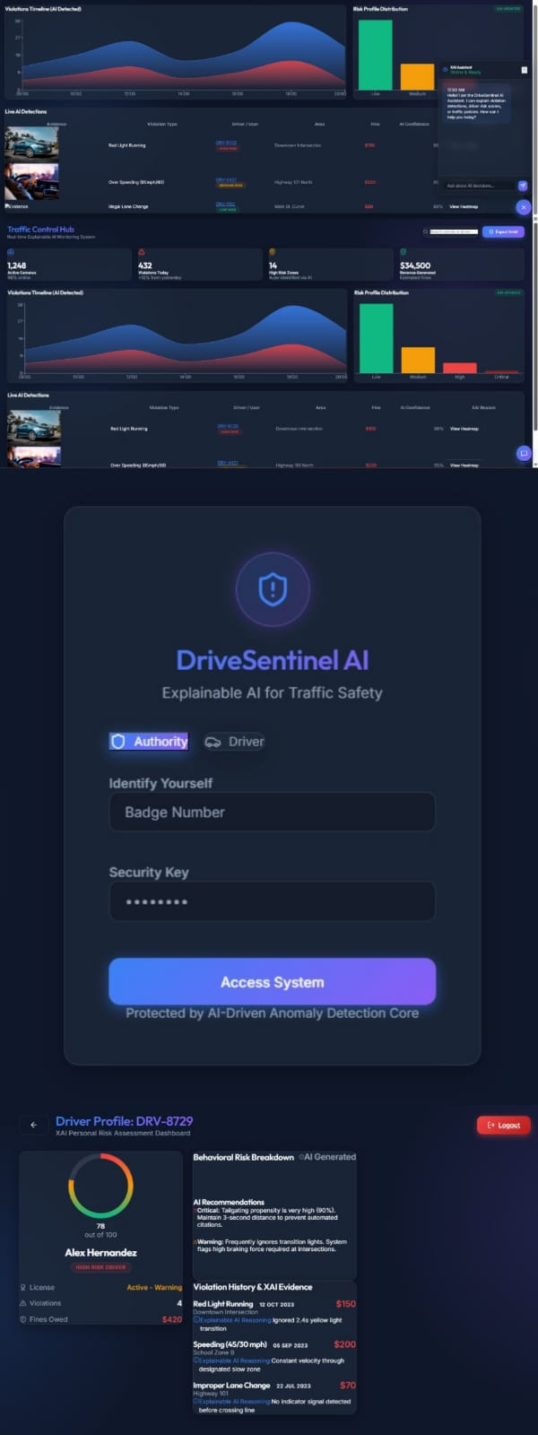

8.3 Challenges Faced:
1. Data Quality and Availability
A major challenge in developing an effective traffic violation detection system is the lack of high-quality, labeled datasets. Real-world traffic data is difficult to obtain due to privacy restrictions and the effort required for manual annotation. Even when data is available, it often suffers from poor quality issues such as low resolution, motion blur, occlusions, and varying camera angles. Environmental factors like rain, fog, nighttime conditions, and inconsistent lighting further degrade image clarity. These limitations directly affect the performance of AI models, as they rely heavily on clean and well-labeled data for accurate training and prediction.

2. Real-time Processing
The system must process continuous high-resolution video streams from multiple cameras in real time, which demands significant computational resources. Achieving low latency while maintaining high accuracy is challenging, especially when detecting multiple violations simultaneously. There is always a trade-off between processing speed and detection precision—faster models may compromise accuracy, while more complex models may introduce delays. Efficient stream processing, frame selection, and optimized inference pipelines are required to meet real-time constraints without degrading performance.

3. Model Accuracy and Generalization
AI models trained on limited or biased datasets may struggle to generalize across diverse real-world conditions. Variations such as different road environments, weather conditions, lighting scenarios, and traffic densities can lead to inconsistent predictions. For example, detecting violations during nighttime or in heavy rain is significantly more difficult. Additionally, occlusion and overlapping objects, such as multiple vehicles in close proximity, make it challenging for models to accurately identify individual violations. Ensuring robustness across all scenarios requires extensive training data and advanced model architectures.
4. Explainability Complexity
Integrating Explainable AI (XAI) into the system introduces additional complexity. While techniques like LIME, SHAP, and Grad-CAM help interpret model decisions, generating explanations that are both accurate and understandable to humans is challenging. These methods can be computationally intensive, making it difficult to provide explanations in real time alongside detection results. Furthermore, presenting explanations in a clear and meaningful way for non-technical users (e.g., drivers or authorities) requires careful design of visualization and interpretation mechanisms.
5. Data Privacy and Security
The system handles sensitive personal data, including driver identities, vehicle registration numbers, and violation history. Ensuring data privacy and protection is critical to prevent misuse or unauthorized access. The system must implement strong security measures such as encryption, access control, and secure data transmission. Additionally, it must comply with government regulations and data protection laws, which may vary across regions. Balancing data accessibility for analysis with strict privacy requirements is a significant challenge.

6. System Integration and Scalability
The architecture involves multiple interconnected components, including traffic cameras, AI processing units, databases, dashboards, and external systems (e.g., government and insurance platforms). Ensuring seamless integration and synchronization across these components is complex. The system must handle large-scale deployments with multiple camera nodes operating simultaneously, often across different locations. Maintaining data consistency, low latency, and reliable communication in such distributed environments requires robust synchronization mechanisms and scalable infrastructure.
7. Hardware and Cost Constraints
Deploying AI-based traffic monitoring systems at scale requires high-performance hardware, particularly GPUs for training and real-time inference. The cost of acquiring and maintaining such infrastructure can be significant, especially for large city-wide implementations. Additionally, storing and processing massive volumes of video data requires high-capacity storage systems and efficient data pipelines. Organizations must balance performance requirements with budget constraints, often requiring optimization techniques such as edge computing, model compression, and efficient resource allocation.
Overall Summary
These challenges highlight the complexity of building a robust and scalable AI-based traffic violation detection system. Addressing issues related to data quality, real-time processing, model reliability, explainability, security, system integration, and cost is essential to ensure accurate, efficient, and trustworthy system performance in real-world environments

9. TESTING STRATEGY

Manual Testing
Manual testing was conducted to verify the functionality and performance of the system. Each module of the application was tested individually to ensure that it works as expected. Inputs were provided manually to check whether the system correctly processes the data and generates accurate outputs. This testing helped identify bugs, verify system behavior, and ensure that the application functions correctly before deployment.

9.1 UI/UX Testing
UI/UX testing was performed to evaluate the usability and design of the web interface. The layout, navigation, and responsiveness of the application were tested to ensure that users can easily interact with the system. Special attention was given to the clarity of displayed results, readability of dashboards, and ease of accessing system features. This testing ensured that the interface provides a smooth and user-friendly experience.

9.2. DEPLOYMENT INSTRUCTIONS

9.2.1 Frontend Deployment (Using Vercel)

The frontend of the application was deployed using the Vercel platform, which provides fast and reliable hosting for web applications. The frontend code was connected to a GitHub repository and deployed through Vercel’s automated deployment process. Once deployed, the web interface became accessible through a public URL, allowing users to interact with the application from any device with internet access.

9.2.2 Backend Deployment (Using Render.com)

The backend services were deployed using Render.com, which supports hosting of APIs and server-side applications. The backend code was uploaded and configured to run continuously on the Render server. The backend handles data processing, model predictions, and communication with the frontend through APIs, ensuring smooth functioning of the system.

9.2.3 Optional: Custom Domain Setup

To improve accessibility and professionalism, a custom domain can be configured for the deployed application. This involves linking a domain name to the hosting platform and updating DNS settings accordingly. A custom domain allows users to access the application using a simple and memorable website address.

9.2.4 CI/CD (Continuous Deployment)

Continuous Integration and Continuous Deployment (CI/CD) were used to automate the process of building and deploying the application. Whenever changes are made to the project repository, the system automatically rebuilds and deploys the updated version. This ensures that the latest improvements and bug fixes are quickly reflected in the live application.

10 EVALUATION AND RESULTS:
10.1 Evaluation Metrics
The performance of the proposed system was evaluated using various metrics such as accuracy, precision, recall, and F1-score. These metrics help measure how effectively the system detects traffic violations and classifies them correctly. The evaluation also considered processing speed, system responsiveness, and reliability to ensure the system performs efficiently in real-world scenarios.
10.2 Results
The implemented system successfully demonstrates the detection and analysis of traffic-related data through an interactive web interface. The results are displayed through a dashboard that presents system outputs and analytical insights. The working prototype of the system was deployed online and can be accessed through the followinglink:
https://coruscating-kangaroo-8eb3c6.netlify.app
The results confirm that the proposed system iscapable of processing inputs and presenting outputs effectively through a web-based platform.

11. APPLICATIONS AND IMPACT
11.1 Use Cases
Applications
1. Smart Traffic Management:
Automates detection of rule violations and assists in real-time traffic control.
2. Law Enforcement & E-Challan Systems:
Helps traffic authorities issue automated fines with clear visual evidence.
. Driver Behavior Monitoring:
Tracks driver habits and assigns risk scores for safe driving assessments.
4. Insurance Risk Assessment:
Provides data-driven insights for vehicle insurance premium calculation.
5. Accident Prevention Systems:
Identifies high-risk drivers or areas prone to violations, enabling preventive measures.
6. Urban Planning & Policy Making:
Supports government decisions using analytics on traffic patterns and violation.
1. Improved Road Safety:
Reduces accidents through timely detection and driver awareness.
2. Transparency & Trust:
Explainable AI provides clear reasons for each decision, increasing fairness.
3. Reduced Human Intervention:
Automates surveillance and violation reporting, saving manpower.
4. Data-Driven Decision Making:
Enables evidence-based planning and enforcement using analytics.

12. RISKS AND VALIDATION
12.1 Ethical Concerns
The adoption of AI-based traffic monitoring systems introduces a range of ethical concerns that must be carefully addressed to ensure fairness, transparency, and accountability in their operation. As these systems rely on automated decision-making to detect traffic violations and assess driver behavior, they hold significant influence over real-world outcomes, including penalties, legal actions, and insurance decisions. One of the primary ethical challenges is fairness, particularly in ensuring that AI models do not produce biased or discriminatory results. Bias can arise from imbalanced or unrepresentative training data, where certain driving conditions, geographic regions, or demographic patterns are overrepresented while others are underrepresented. For instance, a model trained predominantly on daytime traffic data may perform poorly at night, or a system exposed mainly to specific road environments may fail to generalize across diverse locations. Such biases can lead to unfair treatment of certain drivers or groups, potentially penalizing them incorrectly or disproportionately. Therefore, it is essential to use diverse, high-quality datasets and regularly evaluate model performance across different scenarios to minimize bias and ensure equitable outcomes.
Another critical ethical concern is transparency, which refers to the system’s ability to clearly explain how and why a particular decision was made. Traditional AI models, especially deep learning systems, often function as “black boxes,” making it difficult for users and authorities to interpret their outputs. In the context of traffic enforcement, this lack of transparency can reduce trust and raise questions about the validity of automated decisions. For example, if a driver is flagged for a violation without a clear explanation, it becomes challenging to justify the action or resolve disputes. To address this, the integration of Explainable AI (XAI) techniques, such as Grad-CAM, SHAP, and LIME, plays a crucial role. These methods provide visual or feature-based explanations that highlight the factors influencing the model’s decision, such as identifying the exact region in an image that led to a violation detection. By making AI decisions more interpretable, the system enables users, authorities, and stakeholders to better understand and validate its outputs, thereby enhancing trust and acceptance.
Accountability is another fundamental ethical aspect that must be considered. In automated systems, determining responsibility for errors or incorrect predictions can be complex. If the system wrongly identifies a violation or assigns an inaccurate risk score, it may lead to unjust penalties or reputational harm for drivers. In such cases, it is important to establish clear accountability frameworks that define who is responsible for system outcomes, whether it is the developers, operators, or governing authorities. Additionally, mechanisms for human oversight and intervention should be incorporated, allowing authorities to review and validate AI-generated decisions before taking action. This ensures that automated processes do not operate in isolation and that there is always a level of human judgment involved in critical decisions.
Privacy is also a significant ethical consideration, as traffic monitoring systems collect and process sensitive data, including vehicle registration numbers, driver identities, and location information. Improper handling of this data can lead to privacy violations or misuse. To address this concern, the system must implement strong data protection measures such as encryption, anonymization, and access control. Furthermore, it should comply with relevant data protection regulations and ensure that data is used only for its intended purpose. Limiting data retention and providing users with control over their information can further enhance privacy protection.
In addition to fairness, transparency, accountability, and privacy, there is a need to consider the broader societal impact of deploying such systems. While AI-based traffic monitoring can significantly improve road safety and enforcement efficiency, it may also raise concerns about excessive surveillance and reduced individual autonomy. Continuous monitoring of public spaces can create a sense of being constantly observed, which may affect public perception and acceptance of the technology. Therefore, it is important to strike a balance between safety benefits and individual rights by implementing clear policies, maintaining transparency in system usage, and ensuring that surveillance is conducted responsibly and proportionately.
Overall, addressing ethical concerns is essential for the successful deployment and acceptance of AI-based traffic monitoring systems. By ensuring fairness through unbiased data and robust model evaluation, enhancing transparency באמצעות explainable AI techniques, establishing accountability through human oversight and clear responsibility frameworks, and protecting user privacy with strong security measures, the system can operate in a responsible and trustworthy manner. These considerations not only improve the technical reliability of the system but also foster public confidence, enabling the effective use of AI technologies in promoting safer and more efficient traffic management
CONCLUSION AND FUTURE WORK
Conclusion
The project “Explainable AI for Traffic Violation Detection and Risk Scoring” successfully demonstrates the use of artificial intelligence and computer vision for improving traffic monitoring and road safety. The system analyzes traffic-related data, detects violations, and presents the results through a web-based dashboard. By incorporating explainable AI techniques, the system also provides transparency in its decision-making process. Overall, the proposed system provides an efficient and scalable solution for modern traffic management.
Risks
The system involves several important risks that must be carefully managed to ensure reliability and trust. One of the primary concerns is data privacy and security, as the system handles sensitive information such as driver identities, vehicle details, and violation records. Without proper safeguards like encryption, secure storage, and controlled access, there is a risk of data misuse, unauthorized access, or breaches.
Another significant risk is related to system accuracy and reliability. Since the system relies on AI models for detecting violations and generating predictions, there is a possibility of errors such as false positives (incorrectly identifying a violation) or false negatives (missing an actual violation). These inaccuracies can impact decision-making, potentially leading to unfair penalties or overlooked offenses.
Additionally, the system may face operational risks, including technical failures, network issues, or inconsistencies in real-time data processing, which can affect overall performance. To address these challenges, it is essential to implement continuous monitoring, regular model updates, and rigorous testing to improve accuracy over time. At the same time, adopting strong data protection measures and compliance with regulatory standards ensures that user information remains secure. Proper risk management strategies are therefore crucial for maintaining system effectiveness, fairness, and user trust.

13.1 Summary
It presents the development of an intelligent and integrated traffic monitoring system that combines artificial intelligence, machine learning, and explainable AI techniques to enhance road safety and enforcement efficiency. The system is designed to process traffic-related data obtained from surveillance sources, analyze it using advanced AI models, and automatically detect various types of traffic violations. A key feature of the system is its ability to generate visual explanations for its predictions through explainable AI methods, which improves transparency, accountability, and user trust in automated decision-making. By incorporating both detection and interpretability, the system ensures that authorities can clearly understand the reasoning behind each identified violation. Furthermore, the implementation of a web-based platform allows easy access to violation records, risk analysis, and visual insights, making it practical for real-world use. Overall, the project demonstrates how modern AI-driven technologies can be effectively utilized to support traffic authorities in monitoring traffic behavior, enhancing decision-making processes, and promoting safer road environments.
13.2. Future Enhancements
In the future, the system can be improved by integrating real-time traffic camera feeds and expanding the dataset for better model accuracy. Advanced deep learning models can be used to detect more types of violations and improve prediction reliability. The system can also be integrated with smart city infrastructure and mobile applications to In the future, the system can be further enhanced by incorporating continuous real-time traffic feeds from a larger network of cameras, enabling more accurate and timely detection of violations. Expanding and diversifying the dataset with varied conditions (weather, lighting, traffic density) will significantly improve model accuracy and generalization. The use of advanced deep learning architectures, such as transformer-based models and hybrid approaches, can help detect a wider range of violations with higher precision and reliability. Additionally, integrating the system with smart city infrastructure will allow seamless data sharing across traffic management systems, while mobile applications can provide drivers and authorities with instant alerts, personalized insights, and route-based safety recommendations. Future improvements may also include edge computing for faster processing, enhanced real-time analytics, and stronger security mechanisms to ensure safe and scalable deployment provide real-time alerts and traffic insights.

14. REFERENCES
- Grad-CAM: Visual Explanations from Deep Networks via Gradient-based Localization
https://arxiv.org/abs/1610.02391
- A Unified Approach to Interpreting Model Predictions (SHAP)
https://arxiv.org/abs/1705.07874
- Grad-CAM++: Improved Visual Explanations for Deep Convolutional Networks
https://arxiv.org/abs/1710.11063
- Smooth Grad-CAM++: An Enhanced Inference Level Visualization Technique
https://arxiv.org/abs/1908.01224
- Explainable Artificial Intelligence in Computer Vision – Survey
https://www.mdpi.com/1424-8220/25/13/4166
- Deep Learning Book – Ian Goodfellow
https://www.deeplearningbook.org
- Vision Transformer (ViT) – An Image is Worth 16x16 Words
https://arxiv.org/abs/2010.11929
- YOLOv4: Optimal Speed and Accuracy of Object Detection
https://arxiv.org/abs/2004.10934
- Faster R-CNN: Towards Real-Time Object Detection
https://arxiv.org/abs/1506.01497
- Convolutional Neural Networks for Visual Recognition
https://cs231n.github.io/convolutional-networks/
- Explainable Artificial Intelligence for Object Detection
https://arxiv.org/pdf/2303.17249
- Adapting Grad-CAM for Embedding Networks
https://arxiv.org/abs/2001.06538
- Axiom-based Grad-CAM for CNN Visualization
https://arxiv.org/abs/2008.02312
- Explainable Deep Learning for Image Analysis
https://arxiv.org/abs/2307.10506
- Explainable AI Techniques Survey (XAI)
https://arxiv.org/abs/2504.10527
- AI Explainability with Grad-CAM (Practical Guide)
https://www.edgeimpulse.com/blog/ai-explainability-with-grad-cam-visualizing-neural-network-decisions/
- PyTorch Grad-CAM Implementation
https://github.com/jacobgil/pytorch-grad-cam
- AI City Challenge Dataset
https://www.aicitychallenge.org

